# CS 255 System Design Document Template

## UML Diagrams

### UML Use Case Diagram

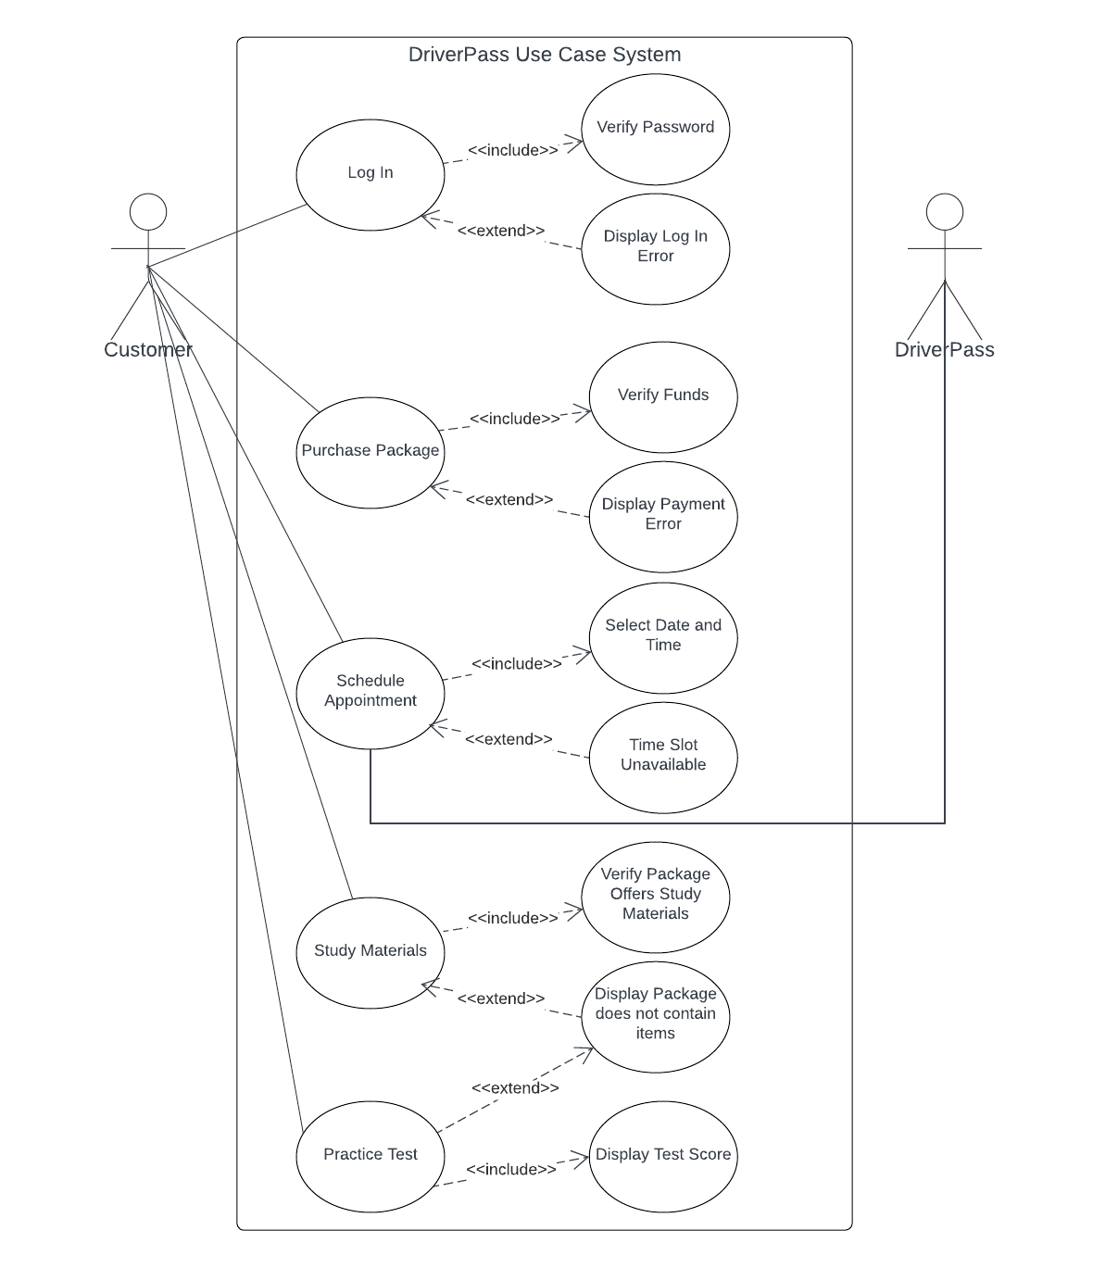

### UML Activity Diagrams

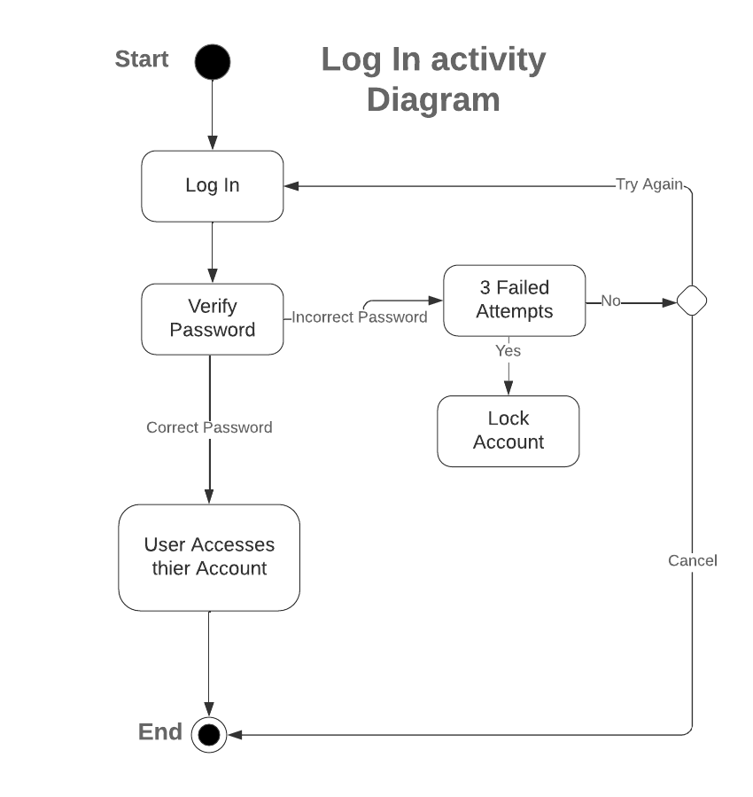

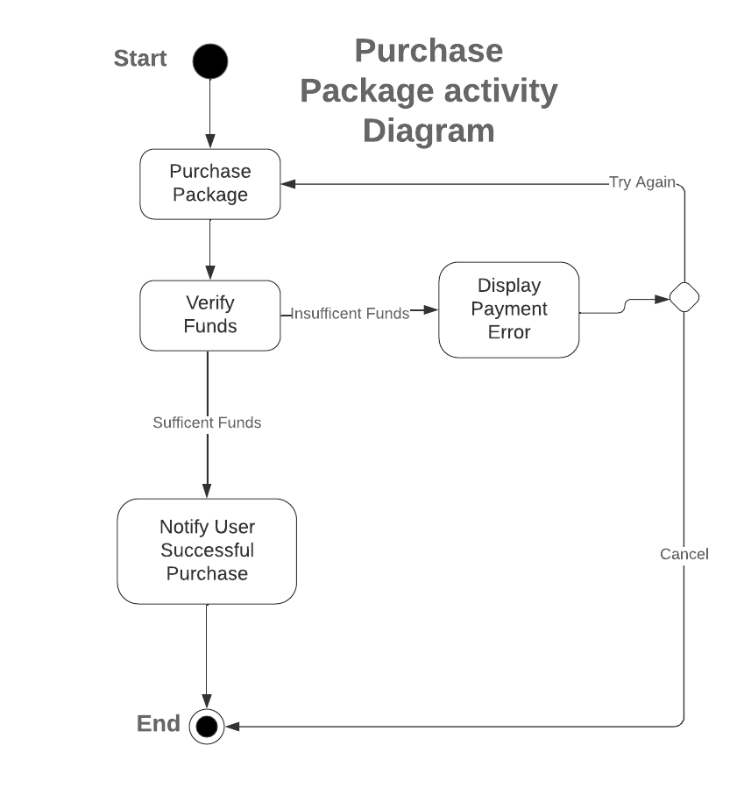

### UML Sequence Diagram

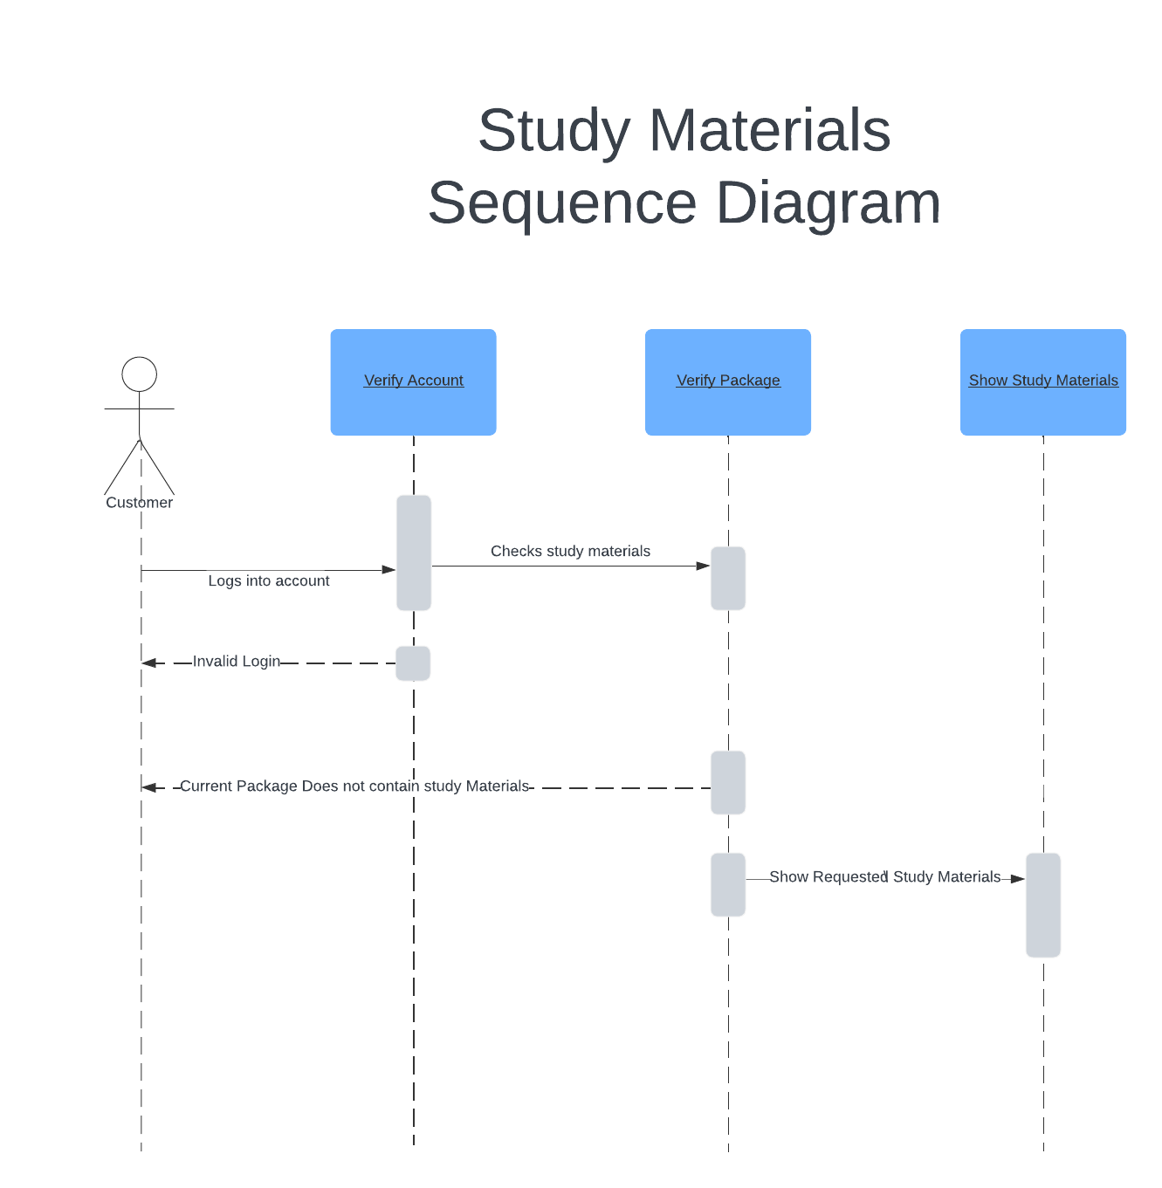

### UML Class Diagram

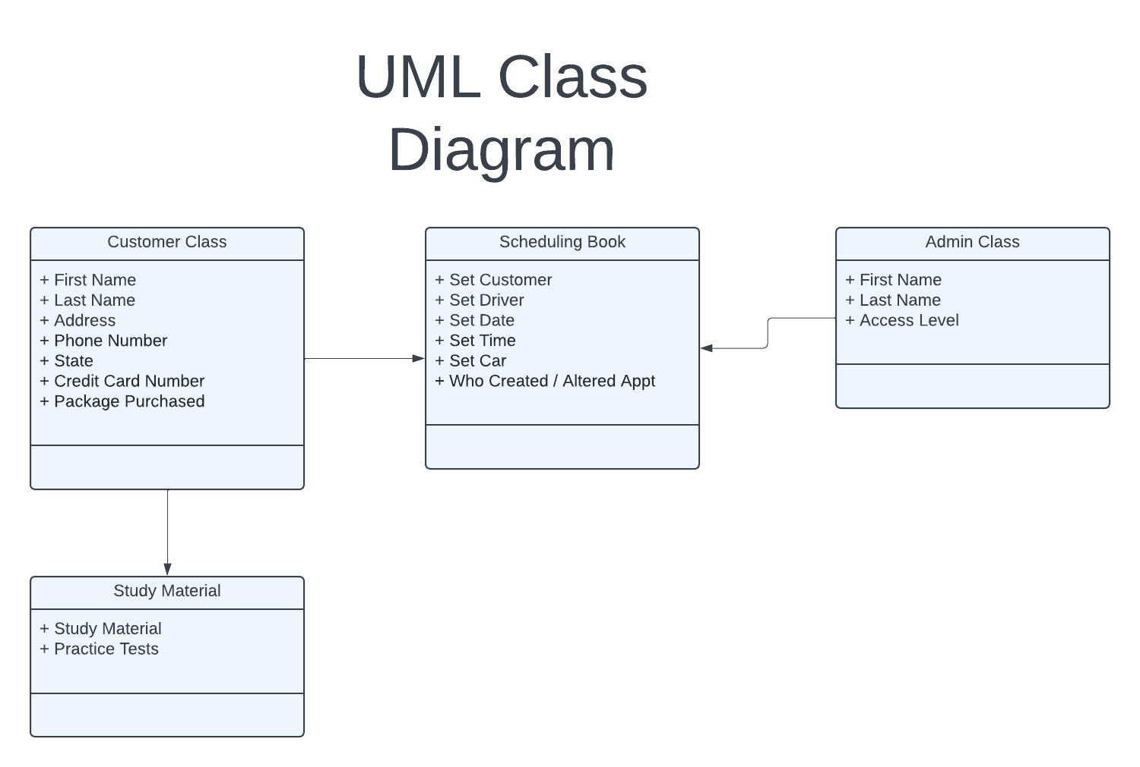

## Technical Requirements

#### **Performance Requirements**

* Environment will be web-based
* System needs to load withing 4 seconds
* System should be updated maintained on a scheduled weekly basis

#### **Platform Constraints**

* The system will run on Windows
* The back end requires a database for maintaining appointments

#### **Accuracy and Precision**

* Users will have a unique username
* Usernames are not case sensitive
* Admin will receive notification if three failed login attempt occur

#### **Adaptability**

* Admin will be able to update appointments via the interface
* The system is set to be able to scale up with more clients
* The IT admin will need a SuperUser or Admin account